How to Buy
- ​Make a xumm wallet on a mobile device and add 26 XRP to the account.

- Add TrustLine with this issuer account: rPfuLd1XmVyxkggAiT9fpLQU81GLb6UDZg
https://xumm.community/?issuer=rPfuLd1XmVyxkggAiT9fpLQU81GLb6UDZg&currency=PALEOCOIN&limit=50101000100.12067

- Go to XRP Toolkit.
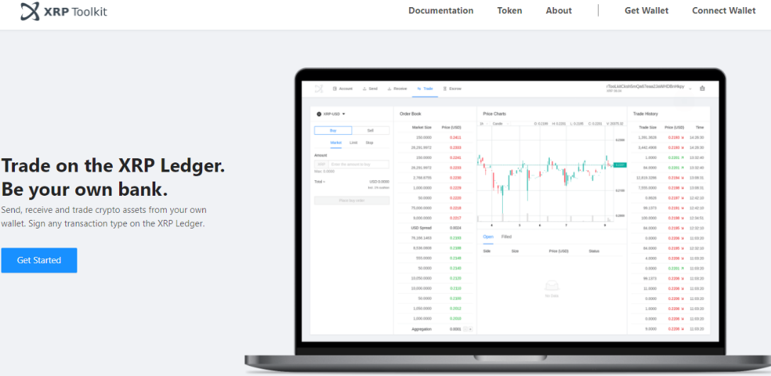

- Click Connect Wallet.
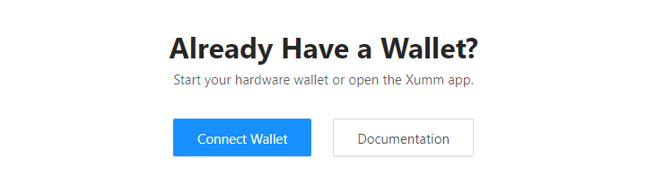

- Connect your wallet by clicking XUMM App and then Connect.
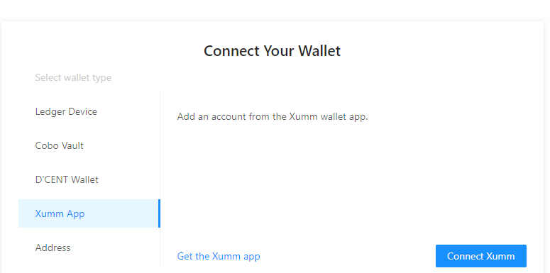

- Sign transaction using XUMM.
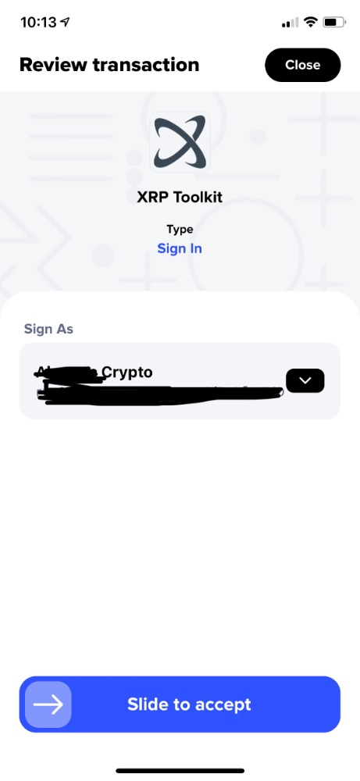

- Click Trade.

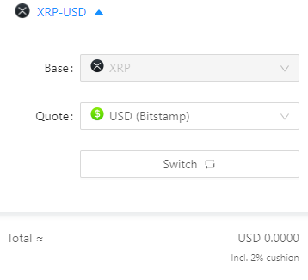
8. Click on the dropdown menu “XRP-USD.” Click where it says “Quote.”

9. Search for “PALEOCOIN.” It will populate the quote box. Then, click where it says, “Switch.”
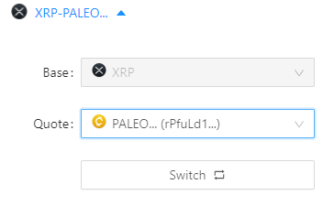
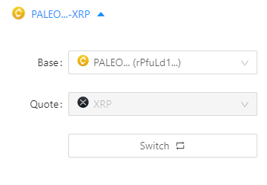
10. Then, click the top drop down arrow again to exit out of the box.

11. Enter the amount you wish to buy and then “Place Order.”
