How to Buy
- ​Make a xumm wallet on a mobile device and add 26 XRP to the account.
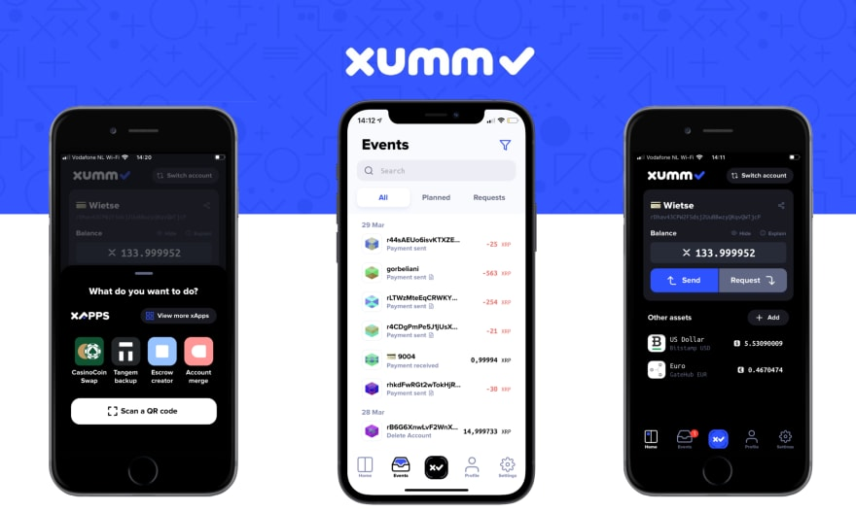

- Add TrustLine with this issuer account: rPfuLd1XmVyxkggAiT9fpLQU81GLb6UDZg
https://xumm.community/?issuer=rPfuLd1XmVyxkggAiT9fpLQU81GLb6UDZg&currency=PALEOCOIN&limit=50101000100.12067
- Once you click the link above, confirm and then sign using the XUMM app.

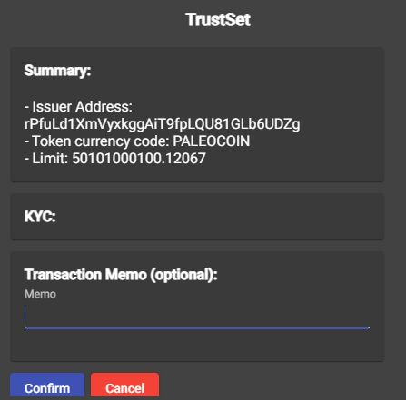
- Go to www.sologenic.org and click “ACCESS DEX”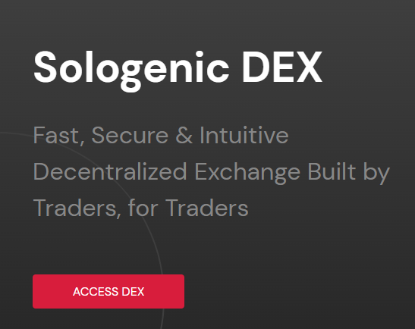
- Connect your XUMM wallet. Option to connect wallet should be in the top right corner or bottom left if you're using your phone.
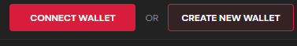

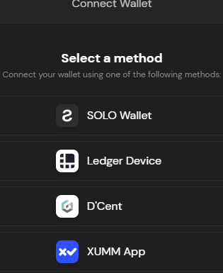

- Sign the transaction using your XUMM Wallet.
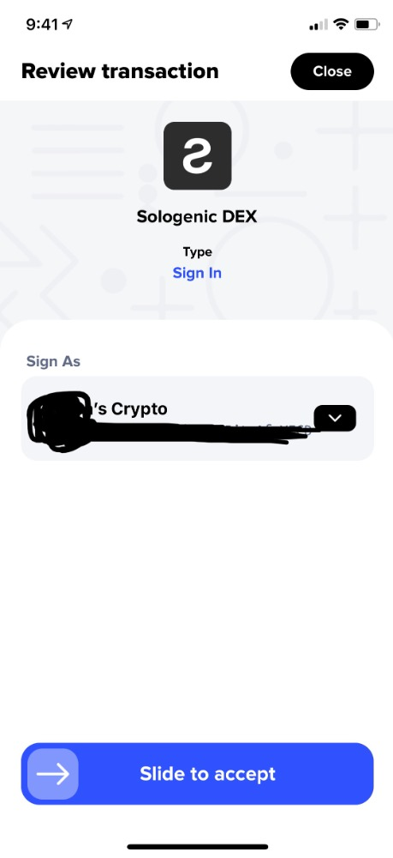
- Go back to Sologenic Dex and click where it says 'Market' - the default is solo/XRP, which will take you to a custom pair.
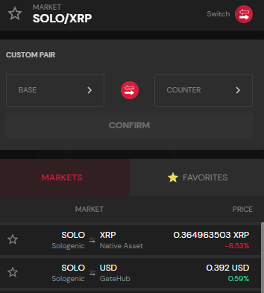

- Select base then click in the empty box that says issuer.
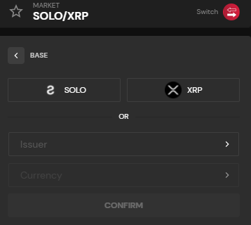

- Search '+other'
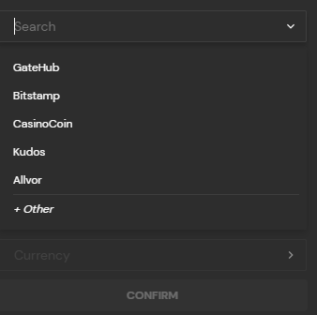

- ​Enter the issuer address: rPfuLd1XmVyxkggAiT9fpLQU81GLb6UDZg
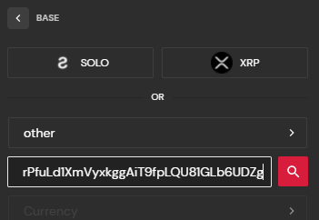

- Click on the box that says 'currency' and search
- Select PALEOCOIN
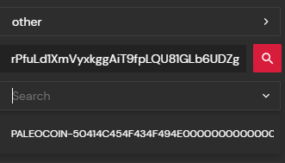

Once selected, click 'confirm' and this will take you to the beginning of the Custom pair.

- Next, click 'counter' then select XRP. Now you’re ready to buy PALEOCOIN



